FORUM FOR AFRICAN WOMEN EDUCATIONALISTS
(FAWE)
RWANDA CHAPTER

“Supporting girls and women to acquire education for development”  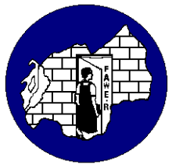  1st Floor, MINEDUC Building  Kacyiru  B.P 6703  Kigali-Rwanda  Tel: 250-0252582514  Fax: 250-0252582514  fawerwa@rwanda1.com  coordinator@fawerwa.org  Website: www.fawerwa.org | GUSABA KUBA UMUNYAMURYANGO WA FAWE RWANDA  APPLICATION FORM TO BE A MEMBER OF FAWE RWANDA  Amazina/Names:  Email Address:  Telefoni/Telephone (+250 )  Ibyo wize/What you studied:  Njyewe ………………………………. nsabye kwinjira mu muryango FAWE Rwanda kandi niba nemerewe, niyemeje gufatanya n’abandi banyamuryango guharanira intego z’Umuryango FAWE Rwanda.  I ………………………………….. apply to be a member of FAWE Rwanda and in case it is honored, I swear to collaborate with other members to support the objectives of FAWE Rwanda.  Umukono/Signature:  Italiki/Date:  Icyitonderwa:  Usabwe gutanga kopi y’impamyabumenyi yawe  You are requested to attach your academic credentials please.  For more information please send an email to coordinator@fawerwa.org or jmaga@fawerwa.org



